MEGESTROL ACETATE INFORMATION PACKAGE FOR COLONY CAREGIVERS
January 2021

This package contains information you will need if you elect to provide megestrol acetate (MA) as a temporary contraceptive for the community cat colony you care for. A few important points:

- This medication is a temporary measure during COVID-19 until the colony can be spayed or neutered.

- We will make every effort to accommodate surgery for your colony through our TNR program, within the constraints of current pandemic operations.

- The list of potential side effects of MA is quite extensive. A closer look shows that most of these problems were recorded using high daily doses, and that even here, serious side effects were uncommon. Anecdotally, colony caregivers have had good success and few problems when using the very low doses we will be prescribing.

- To ensure that the cats are doing well, we will call you regularly to monitor progress.

- The decision to use MA is based on a risk-benefit assessment. Our veterinarians will discuss this with you during the telemedicine consultation.

- Please read the attached disclosures before the consult. Note that the disclosures do not need to be signed and returned. Verbal consent will be obtained during the telemedicine consult.

Before prescribing MA, we require:

- Photographs of the colony site, ideally including photos of the cats

- A list of the cats in the colony, with information identifying the cats to the extent possible (sex, colour, special identifying features)

Email both these addresses any urgent concerns arise:

shelteroutreachvet@torontohumanesociety.com
acampbell@torontohumanesociety.com

MEDICAL DISCLOSURE

Name: ___________________

Number:___________________

Name:________________ Date: _________________

Number:______________

MEGESTROL ACETATE

What is this about? A medication called megestrol acetate has been prescribed. This is a synthetic progesterone and is used to stop heat and prevent pregnancy in female cats until they can be spayed. It is NOT suitable as a long-term solution because of the potential for side effects. The most common major side effect in cats that are prescribed this drug is temporary diabetes, which resolves when the medication is stopped.

This drug must not be given to kittens under 4 months of age, and should be avoided in pregnant cats to the extent possible. There is the potential in pregnant cats to cause abnormalities or death of the kittens in the uterus, and difficult births (dystocia), which can potentially cause death of the cat and require emergency care. These complications are likely to be uncommon at the low dose prescribed.

The medication will not affect milk production in a mother cat who is nursing kittens, and is not harmful to male cats who take it occasionally by mistake (for example in a colony situation).

The medication can be absorbed through the skin – use gloves when handling. Gloves can be thoroughly washed and re-used.

What has THS done so far? Telemedicine consultation to determine whether this medication is suitable for the cat(s) concerned. Explained benefits, limitations and risks of the medication.

What still needs to be done? Administer strictly according to the instructions on the label. Contact us if there are any concerns.

More information: Using Megestrol Acetate During COVID-19 https://acc-d.org/available-products/progestin-contraceptives/covid-19-updates

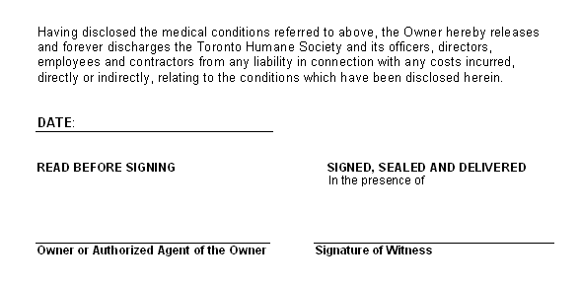

MEDICAL DISCLOSURE

Name: ___________________

Number:___________________

Name:________________ Date: _________________

Number:______________

EXTRA-LABEL DRUG USE

__________________________ has been prescribed or dispensed to treat _____________________________ .

Extra-label drug use means that a medication is being used for a purpose it was not originally meant for. The manufacturer has not specifically tested it or cleared it with Health Canada for this use. Extra-label drug use can mean several things:

- The drug is labelled for a different species but for the same purpose
- The drug is labelled for a different purpose
- The drug is being used in a different way than the label, or example, in a compounded form or at different dose or duration

This can sometimes lead to side effects as a result. Extra-label drug use for pets is extremely common. Many extra-label drugs have been used in this way for many years.

The prescribed medication is considered to be the best treatment for this condition, but some side effects may occur. Please ask the technician or veterinarian if you have any further questions after going through this disclosure with them. Please contact your veterinarian if any problems arise.

Having disclosed the extra-label drug use referred to above, the Owner hereby releases and forever discharges the Toronto Humane Society and its officers, directors, employees and contractors from any liability in connection with any adverse reactions or costs incurred, directly or indirectly, relating to the extra-label drug use which has been disclosed herein.

DATE:__________________________________

READ BEFORE SIGNING SIGNED, SEALED AND DELIVERED
In the presence of

________________________________________ ______________________________________
Owner or Authorized Agent of the Owner Signature of Witness

